Spartan Fresh Grocery Shopping Site

**USER GUIDE**

**Introduction**

Going to a physical grocery store is a lot more work than it used to be. We now need to wear face masks, bring antibacterial wipes, and prepare for long lines. Our solution to this problem is rather simple: skip the trip altogether. With our online grocery store, a user, from the comfort of their home, can navigate to our site, browse the various food items and products, add to their shopping cart, and finally, checkout what they wish to purchase.

**Scenarios**

**Scenario 1**

Jenny is a twenty-eight-year-old single mother. She has three children, all under the age of fifteen. It’s difficult for Jenny to stay on top of groceries. She doesn’t eat very much, but her two growing boys and daughter do. She goes to her local grocery store about once a week, twice if it gets really bad. But every time, it’s a hassle. She must buckle up all three kids into the backseat, drive to the store, and shop around. They grow impatient quickly and want to head back before long. This makes it difficult for Jenny to properly shop for groceries. She doesn’t want to pay for a babysitter, but she does want a way around the drive. A new solution she’s considering is a website that delivers groceries to her door. It will take away a lot of stress and make it easier for Jenny to stay on top of her hungry children’s needs.

After finding the website of OFS (Online Spartan Fresh), Jenny wanted to see if all the products she wanted were available. She views the main page and searches for items that she would normally buy in person. After being satisfied with the displayed collection, Jenny clicks the register button to make an account. She inputs all her information, signs up, and logs in. She navigates through the category pages, adding all the items she would normally buy. In the cart, she adjusts the number of apples she added because she selected too many. She sees that her current cart is less than 20lbs (18lbs)) so she does not add anymore items to avoid the shipping fee. She goes to the checkout page, where she enters her address and payment information. After confirming the cart and personal information in the checkout page, she places her order.

**Scenario 2**

Tom is an eighty-year-old man. He lives with his wife in downtown San Jose. He is retired but used to teach at a local high school. He is familiar with navigating his computer and the internet but prefers to live free from technology. Tom and his wife rarely leave the house because they are at-risk elderly. Before the pandemic, Tom and his wife would buy groceries twice a month at their local grocery store. They would browse the aisles and pick out whatever they needed for the next two weeks. However, since the pandemic, Tom has had to rely on his neighbors to bring him groceries. He would like to be able to choose and buy groceries himself in a safe way.

When OFS’s website became available, Tom was thrilled. Every week he places orders, buying his meats and dairy products for most of his meals. However, Tom has decided to move in with his son. He needs to change his shipping address and use his son’s card information in case his balance is low. So, Tom decides to navigate to the OFS website, login, and go to the user center. There, he chooses the option to add a new shipping address. He adds the necessary information and sets it as the default. Tom then adds a new payment method but keeps the previous as the default. Now, next time Tom checks out, he has his new address set and his son’s card ready in case of a low card balance.

**Scenario 3**

Remmy is a forty-two-year-old employee who has been working at OFS for the past four years. He lives in downtown San Jose, just a few minutes from the grocery store. He has a degree in Business Administration, with a focus on management. In his job, he oversees inventory and keeps track of when new stock arrives and when items are no longer sellable. He keeps track of all items through Microsoft Excel, which is the only software he is comfortable with. With OFS going online, Remmy would like a way to be able to update inventory online, so customers can see what is in and out of stock. He would prefer a system that is simple to use and operates like how he can update inventory in Microsoft Excel.

After OFS adopted a new website, Remmy’s job became much easier. Every two days, when new stock arrives, Remmy logs into the website using his admin account. He examines the new stock arrival in the store, and for each item, adjusts the stock from the Edit Product management page. Yesterday, Remmy was notified the shop had received a new product, Wagyu Beef. Remmy weighs the item, comes up with a description, and finds an image online for this item. He then navigates to the Add Product page, where he enters all the necessary information. After submitting, the shop displays the new Wagyu Beef product, and each item stock is up to date.

**Functionalities**

**Navigation Bar**



The navigation bar appears in most pages and acts as a portal of the website. The website logo on the left leads to the front page. The search functionality shows results matching keywords with product names and descriptions. The login status decides the functionalities of the buttons on the right. When the user is not logged in, both buttons on the right trigger the login/registration modal. When the user is logged in, the user button displays the first name of the user and leads to the user center. The cart button displays the current shopping cart item count and leads to the shopping cart.

**Product Info Card**

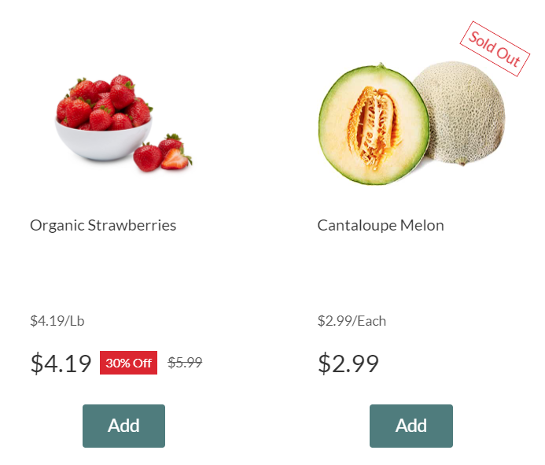

The product info card provides a comprehensive overview of the product information, including product image, name, unit price, original price, discount, and discounted price. The add button allows the user to add one selected product per click if there’s enough item in stock.

**Registration  
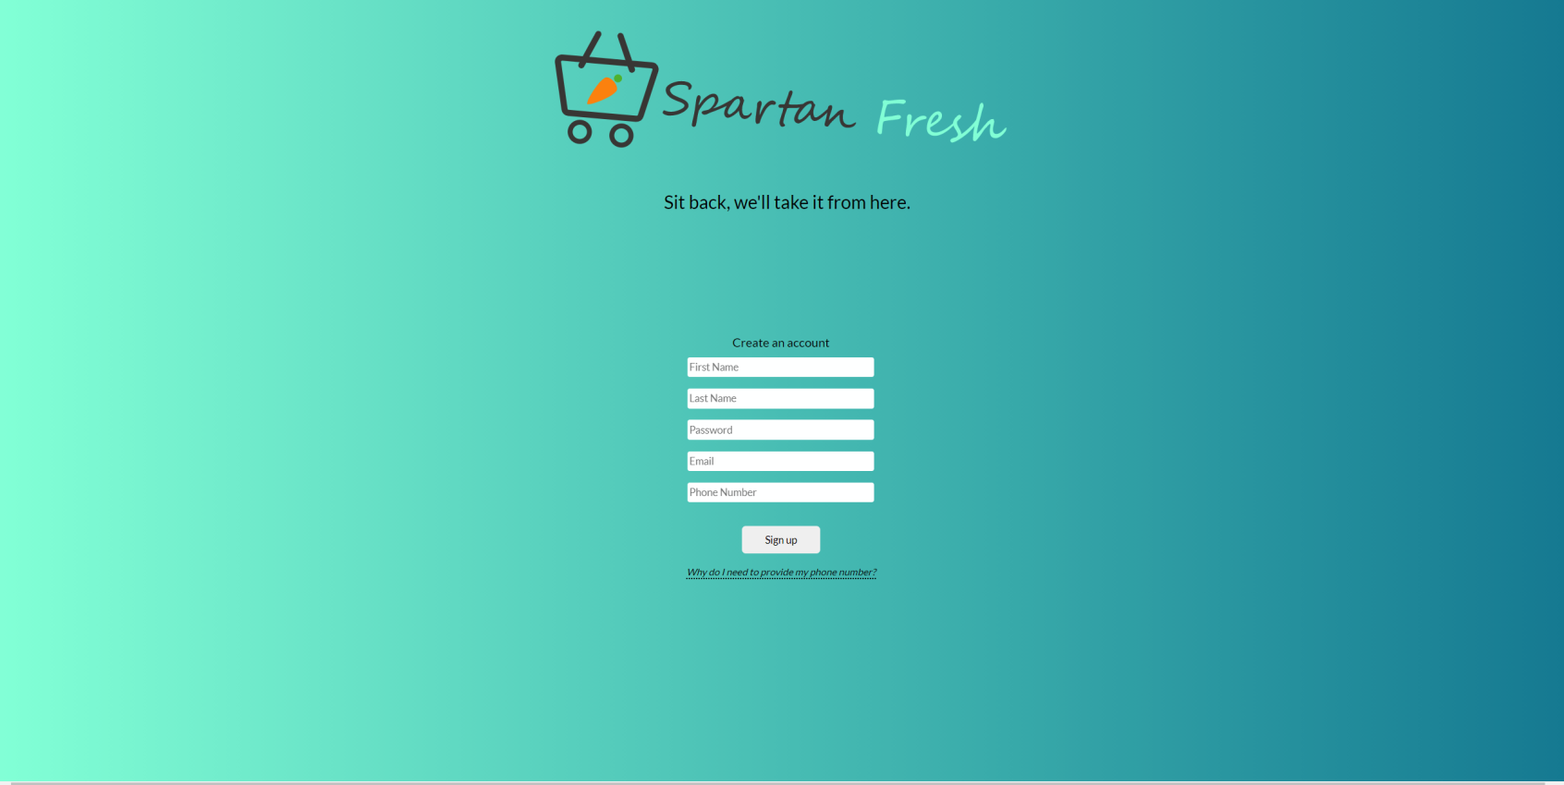**

If the user does not have an account, they are directed to the registration page. There are five required fields: first name, last name, password, email, and phone number. The email and phone number must be written in certain formats. If the user does not follow the formats or does not type anything at all, a helpful message will appear above the required field. The form submission will only go through if everything is entered correctly. If the email is a duplicate, the user will be notified and redirected back to the registration page. Otherwise, the user will be directed to the login page so they can sign in.

**Login**

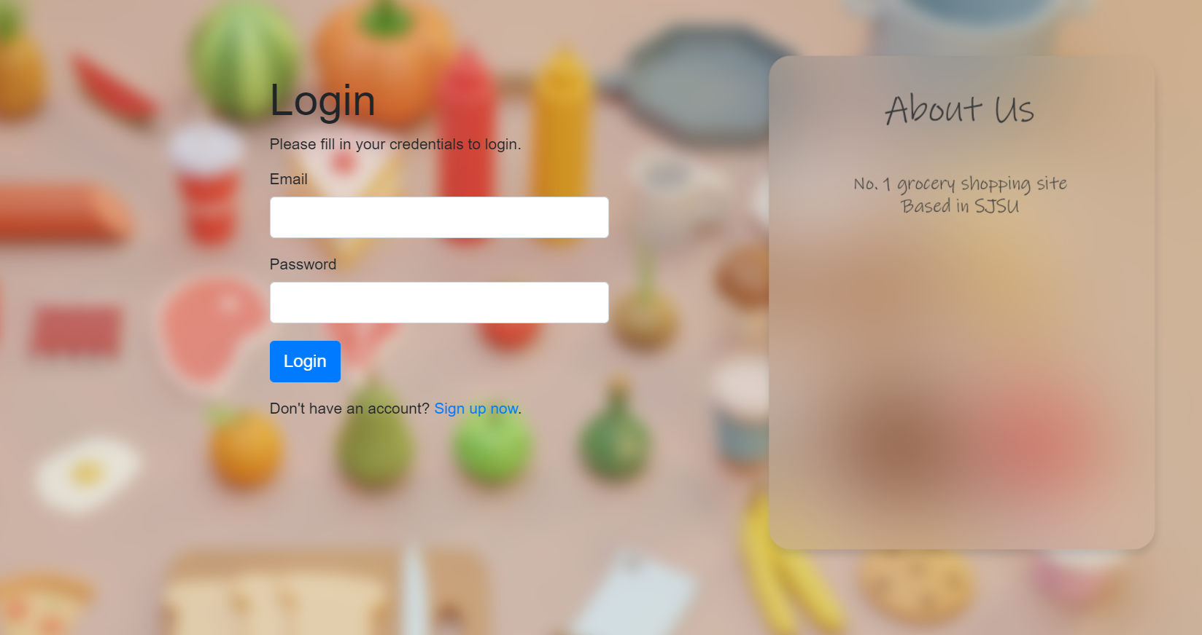

There are two required fields: email address and password. The email address must be in the correct email format. The passwords user entered will be encrypted in the server and stored in the database. If the email and password are not matched or the email address does not exist in the server. The warning message “Invalid email or password” will appear. To sign up an account, the user clicks on the “Sign up now” button. It will direct to the registration page.

**Category View**

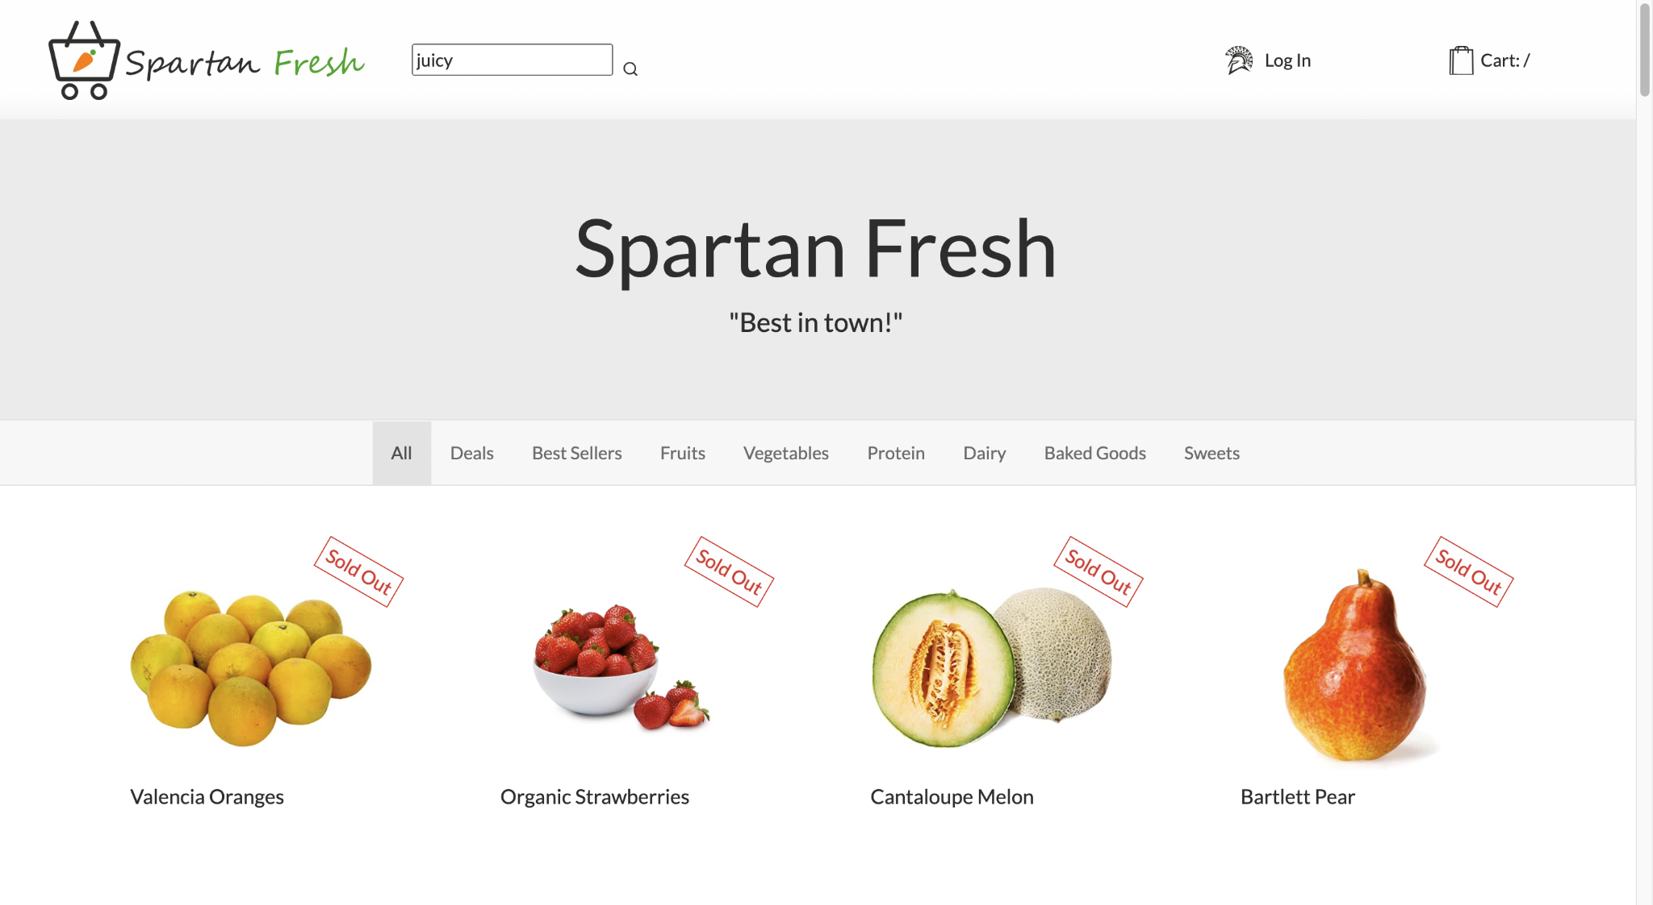:

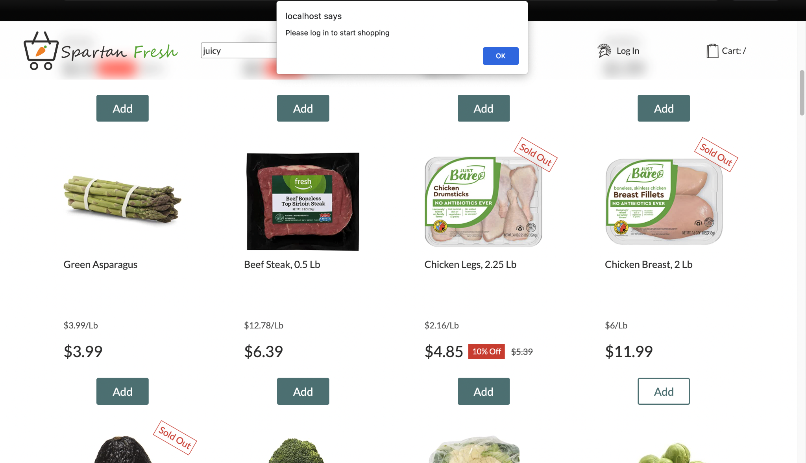

Users can view the main category page while not logged in. Here they have the option to choose between categories, search, and click on items for more details. However, guest users cannot add items or access the User Center/Cart. If attempted, the user is alerted “Please log in to start shopping.”

**Search Feature**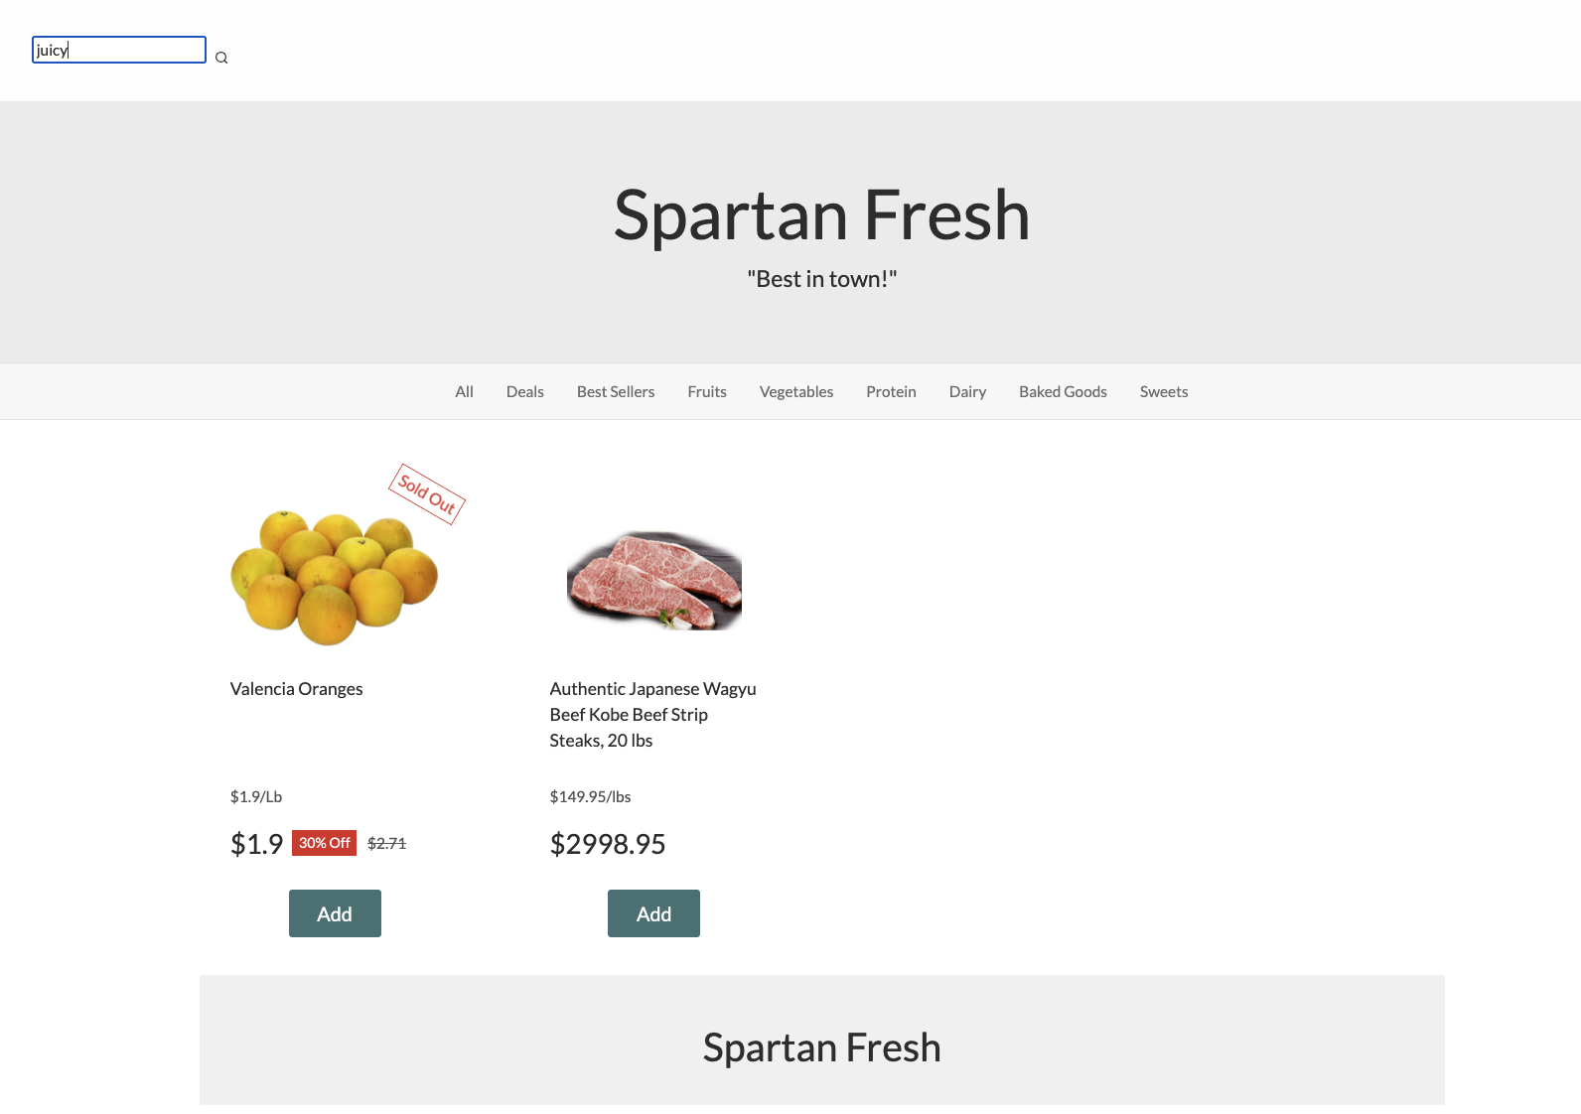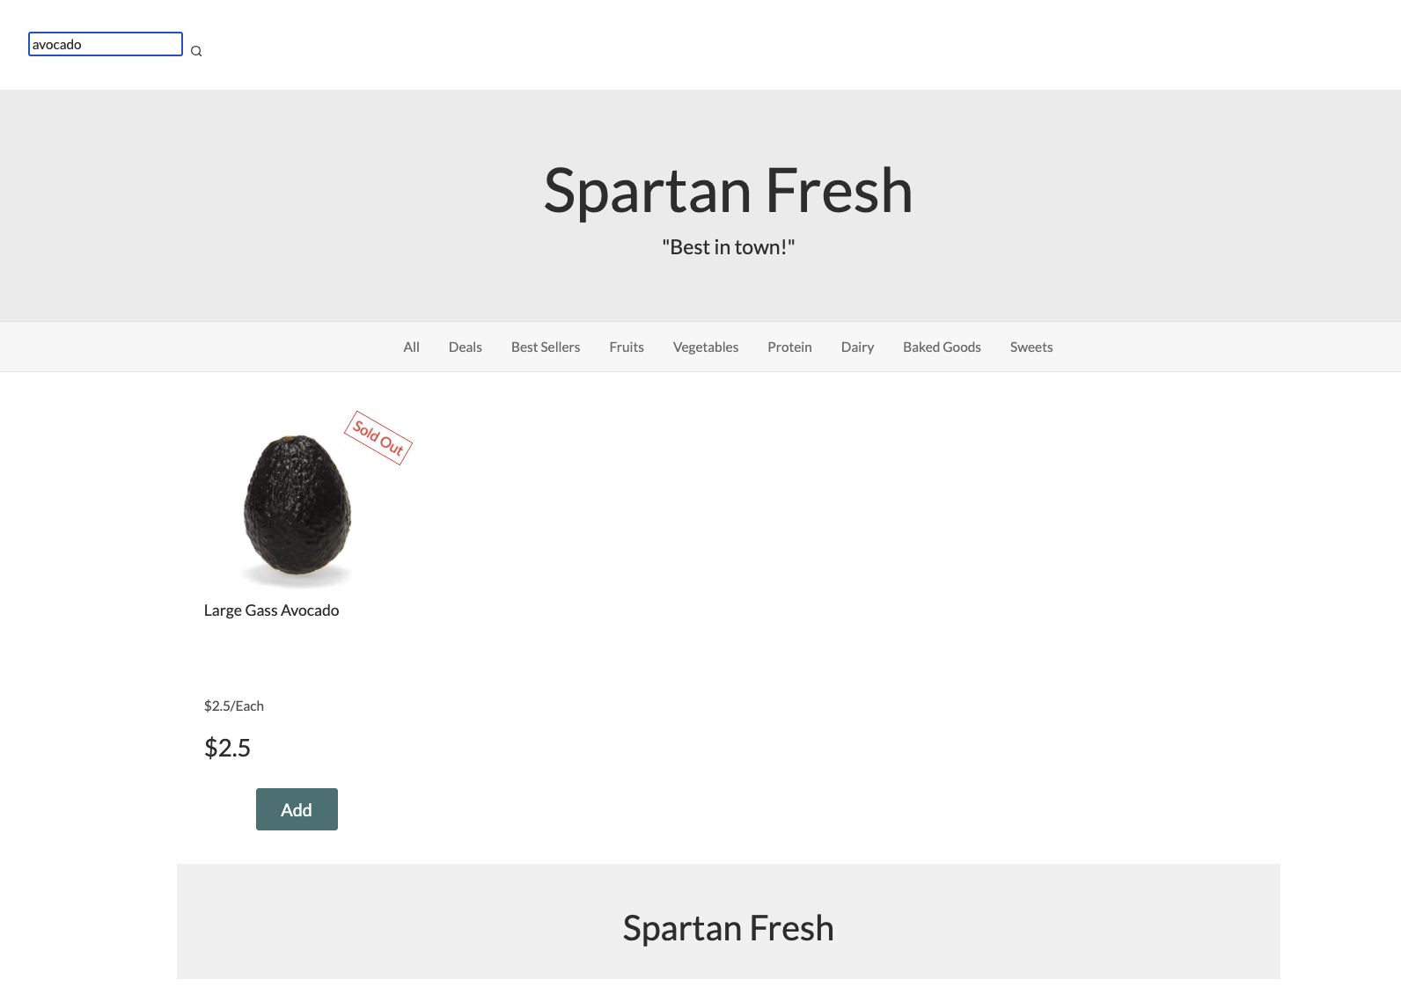

Users can search for keywords or specific items using the top search bar. For example, the top screenshot shows a user searching for “juicy” items. In the bottom screenshot, a user searches for an “avocado” specifically.

Once logged in, users can add one item at a time by clicking the add button. They are alerted which item has been added to the cart. The top-right cart quantity will also reflect the total quantity in cart. Additionally, logged in users can click on their name to access the User Center, the cart icon to view/modify their cart, or log out to end their shopping session.

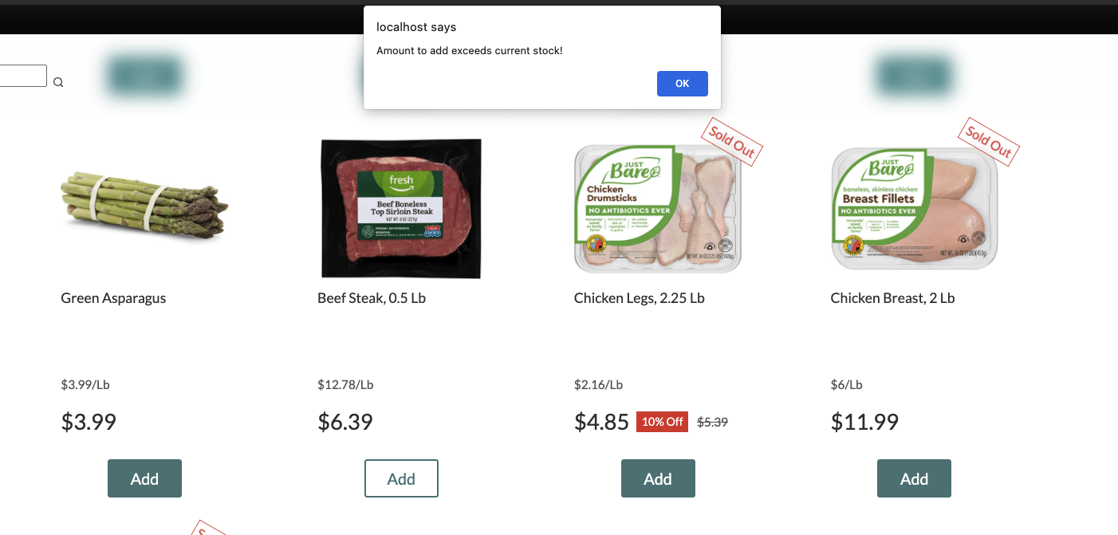

Users cannot add an out-of-stock item to cart or add if their quantity in cart would exceed the inventory stock. User is alerted “Amount to add exceeds current stock!”

**Product Detail Page**

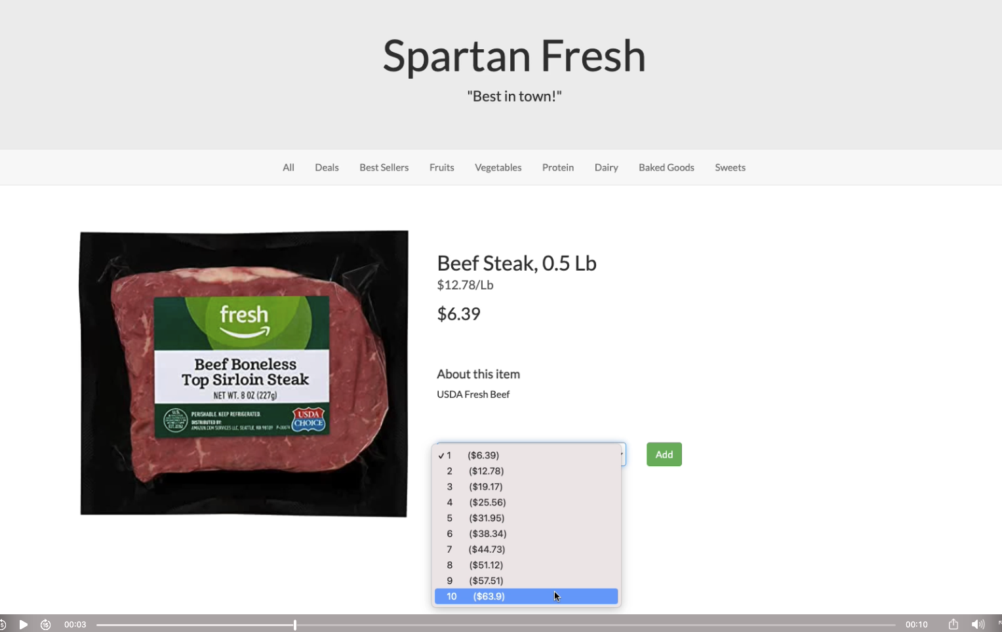

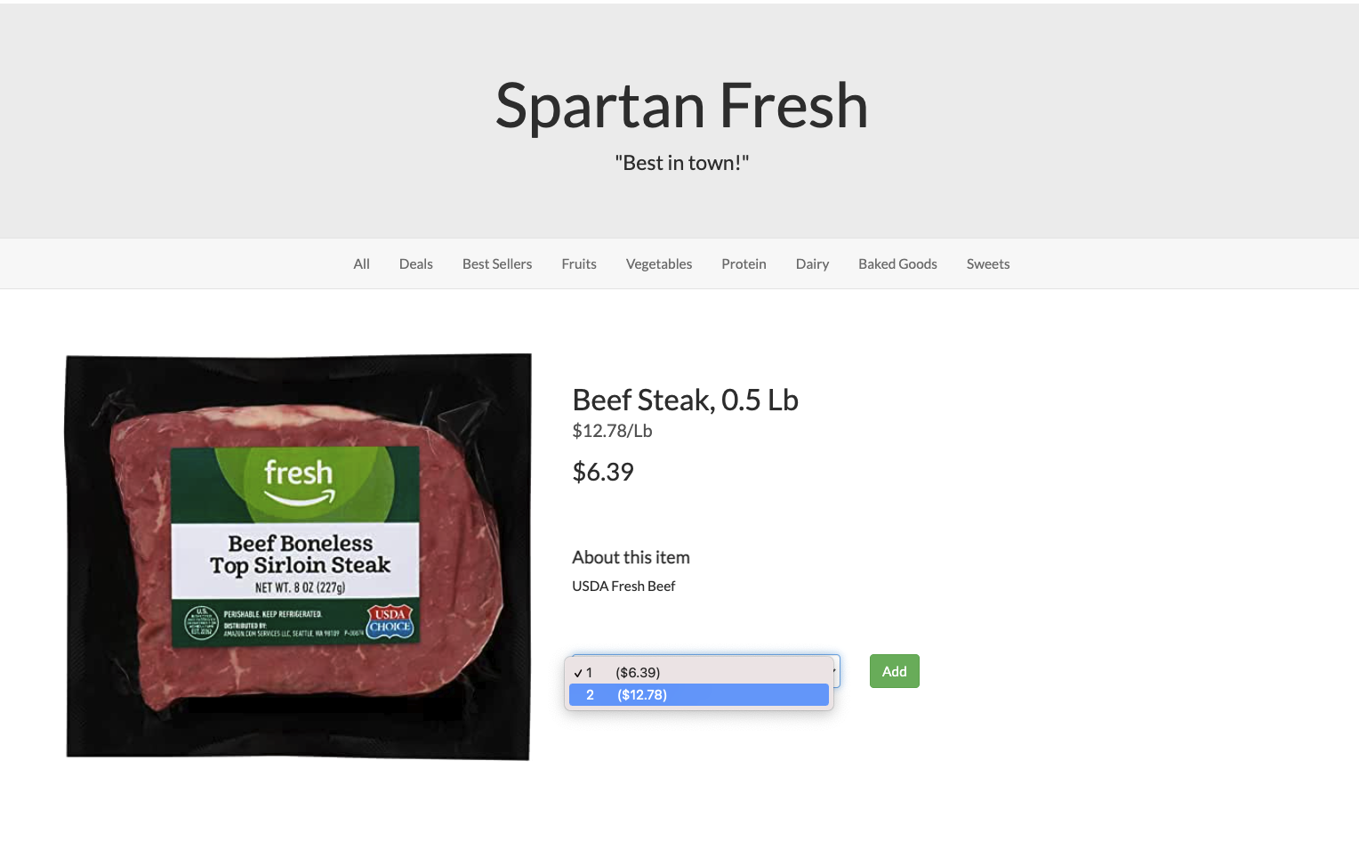

Users can then click on an item to view an individual item detail page. A brief description is provided, and users can choose to add up to 99 items at once (if there is enough stock), or up to the amount left in inventory. After adding an amount to the cart by clicking the add button, it will be reflected in their cart icon quantity and the quantity available to add next time. If stock becomes unavailable before one can add, there is also backend validation to ensure an invalid amount cannot be added.

**Shopping Cart**

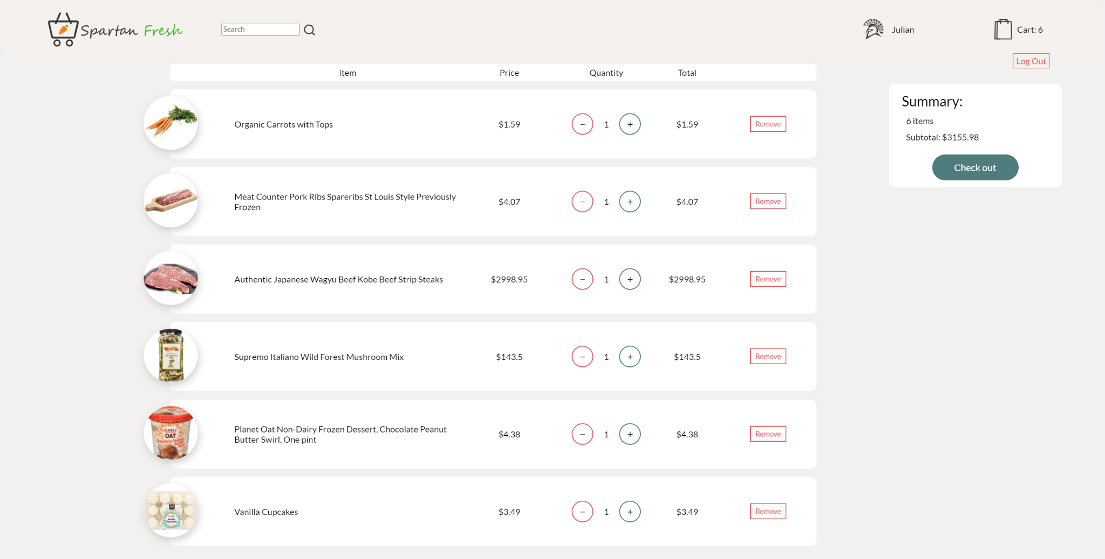

In the shopping cart page, the user can modify the quantity of products or remove them. The subtotal per product and total subtotal are shown. The user is not allowed to add more items to the shopping cart than the current in-stock amount.

**Checkout**

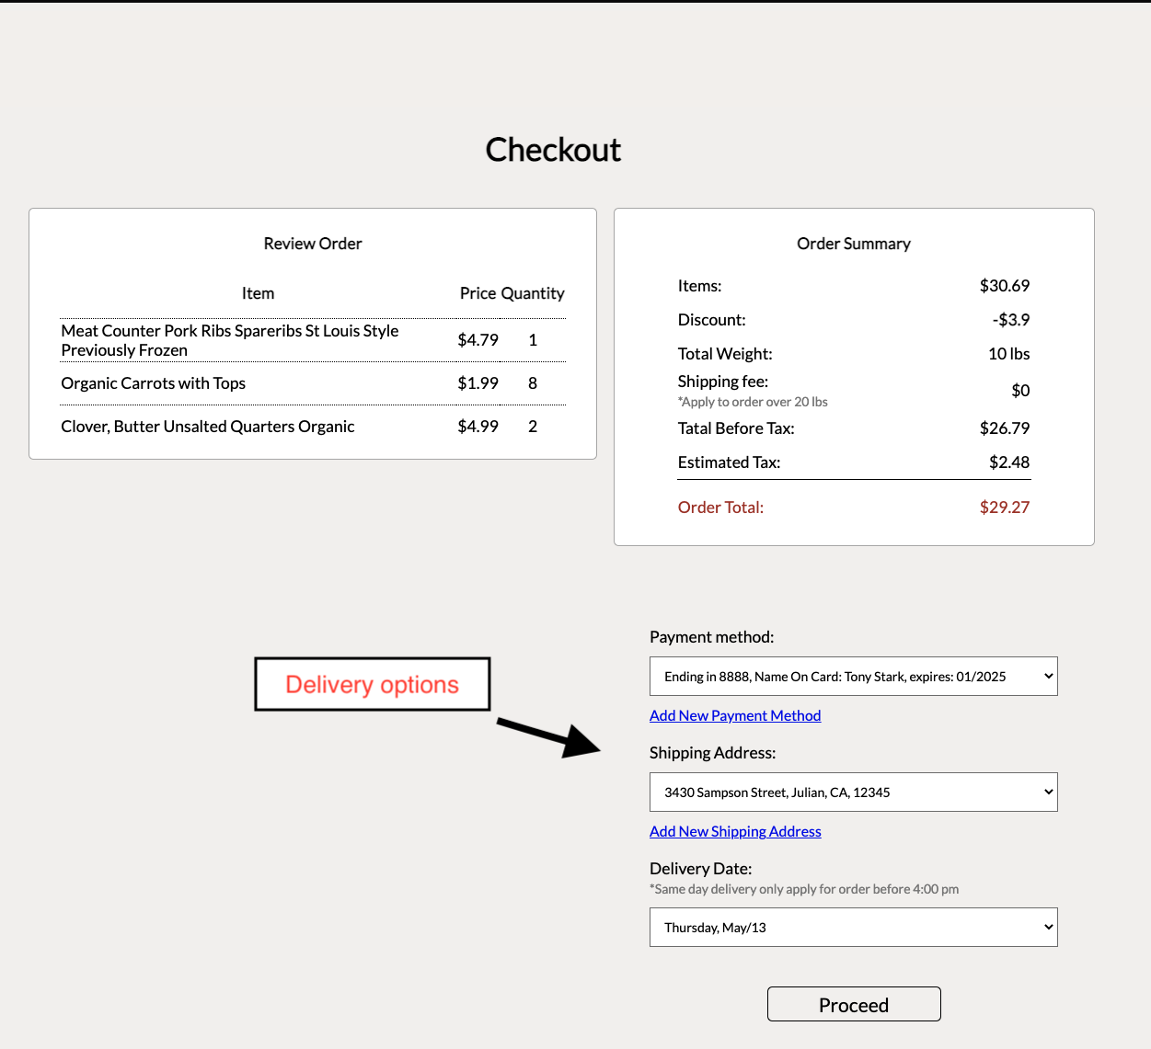

The user will see the order items and the order summary, including tax, discount, shipping fee (only apply for order weight over 20 pounds), and total on the checkout page. Then, the user can select the payment method, shipping address, and delivery date for this order. Note that same-day delivery only applies for orders before 4:00 pm. If the user does not have any payment method or shipping address, or wants to add a new delivery option, he/she can add by clicking the “Add New Payment Method” and “Add New Shipping Address”.

After clicking the “Proceed” button, the user will see the chosen delivery instruction and a “Place Order” button. By clicking this button, the order will be placed! Then the user can go back to the front page and continue shopping.

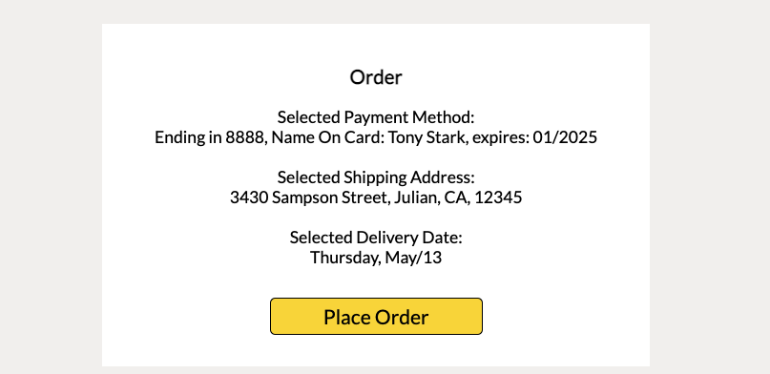

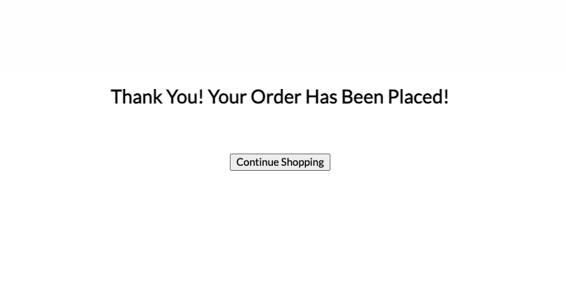

**Add Payment**

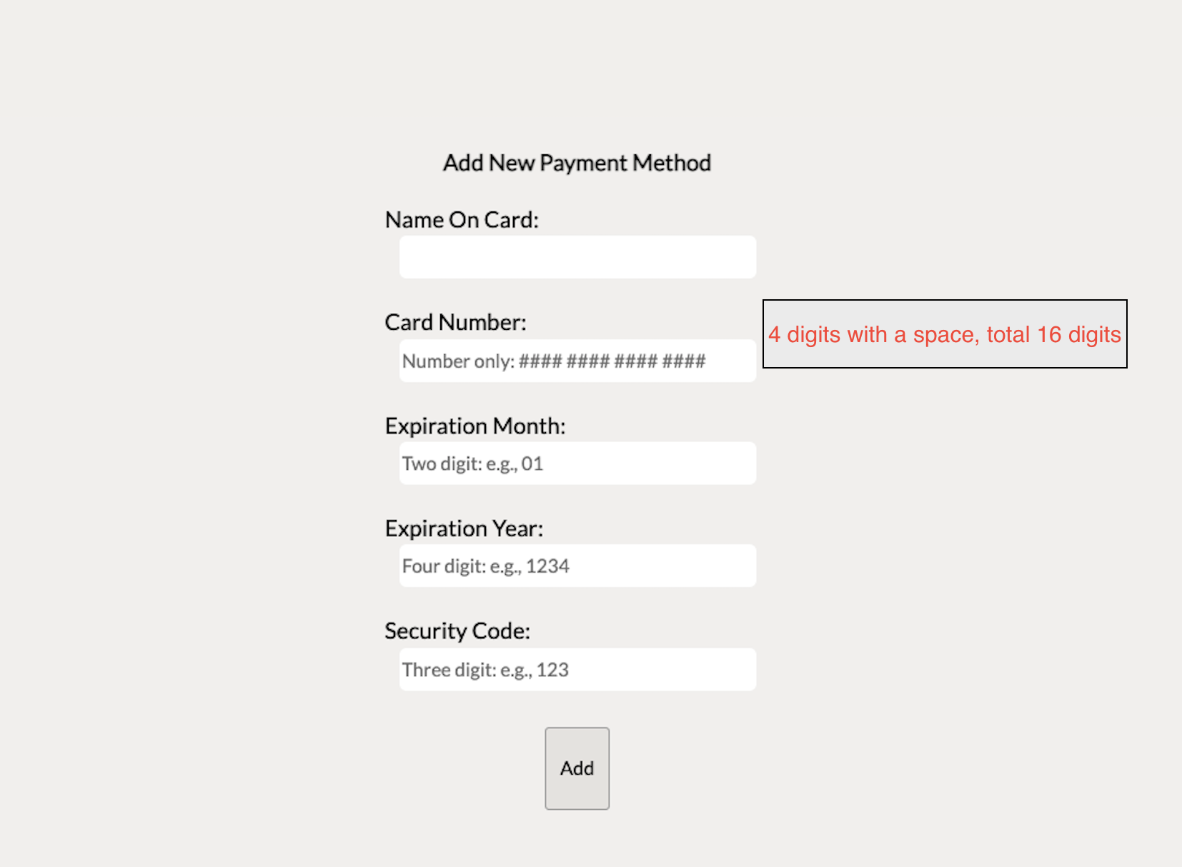

There are five required fields: name on card, card Number, expiration month, expiration year, and security code. The Card Number, Expiration Month, Expiration Year, and Security Code need to be written in a certain format as the hint, or the user cannot add a new payment method.

**Add Address**

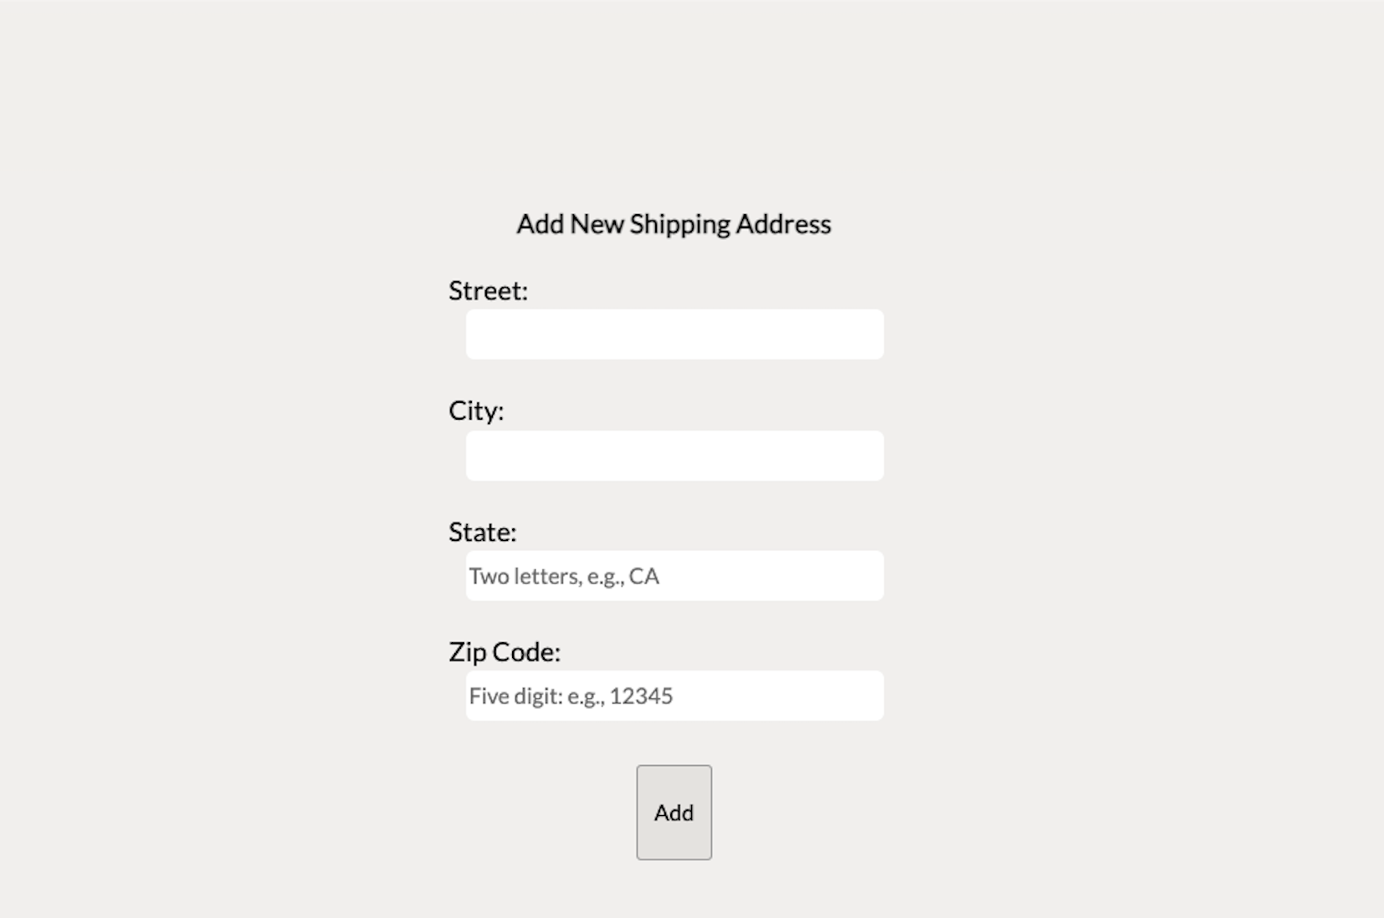

There are four required fields: Street, City, State, and Zip Code. State and Zip Code must be written in a certain format as the hint, or the user cannot add a new shipping address.

**User Center**

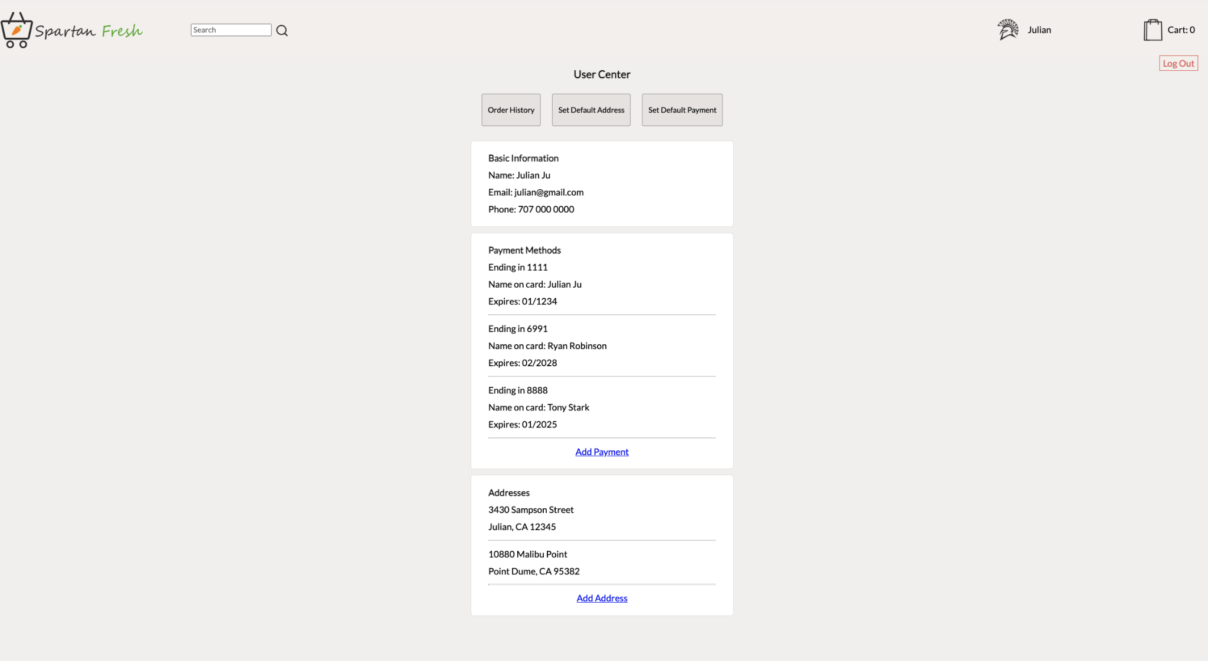

The first page of the user center has the user’s basic information, payment methods, and addresses. The user can add payment or address in the user center either. There are three buttons on the top: “Order History”, “Set Default Address”, and “Set Default Payment”.

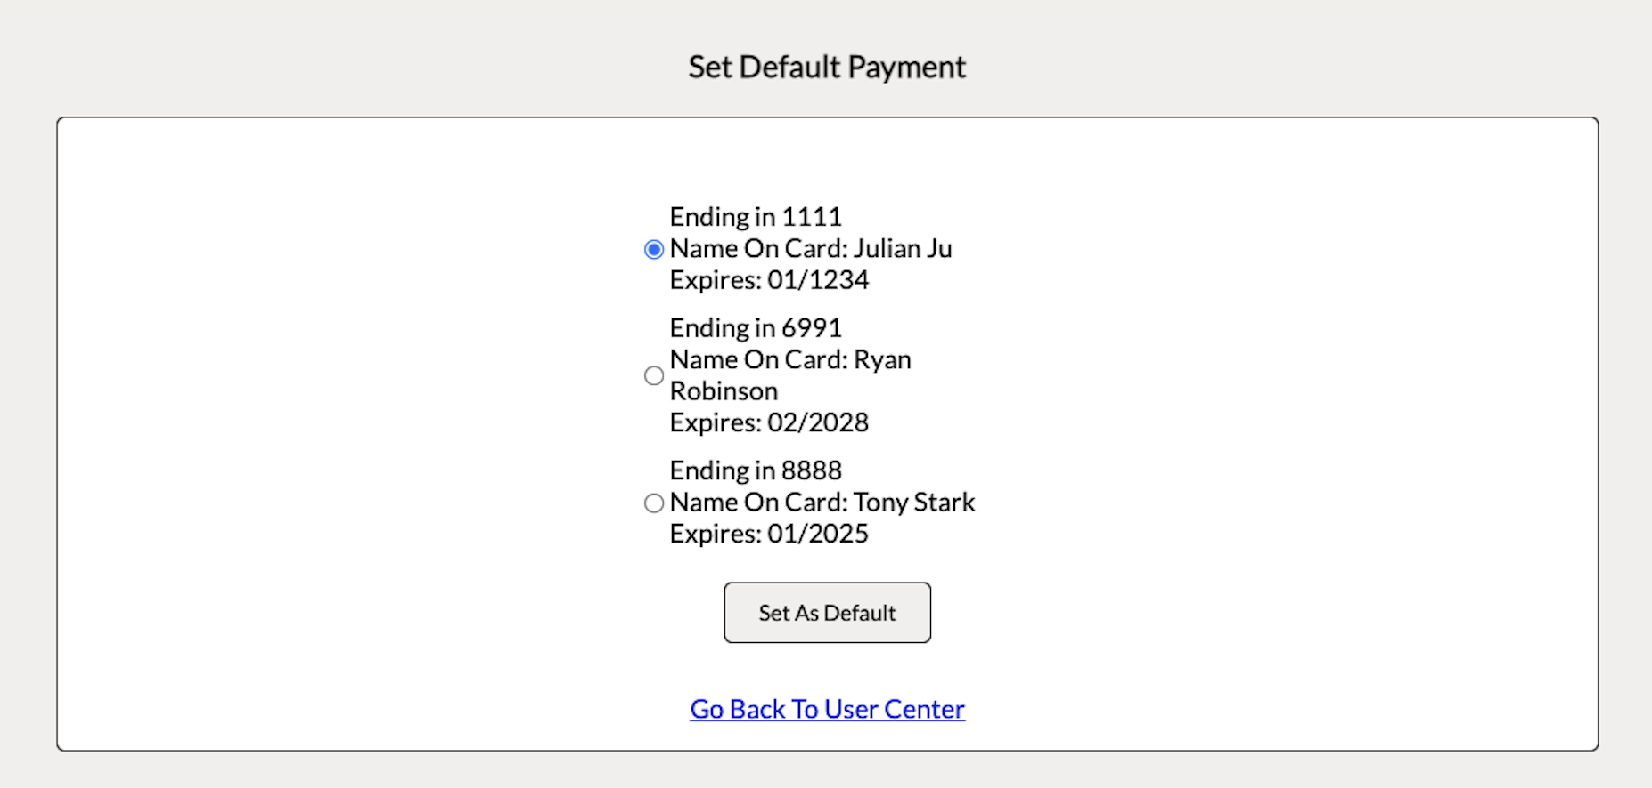

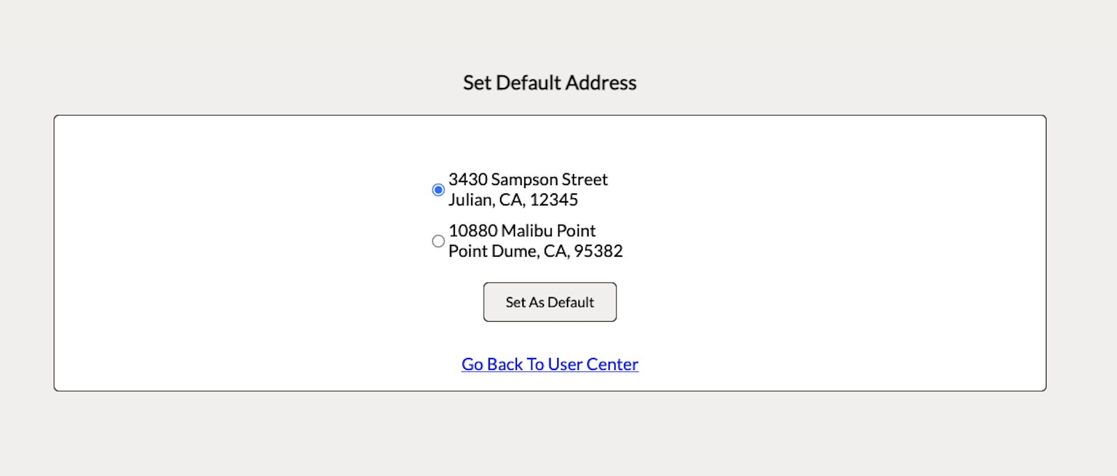

The two “Set Default” buttons will bring the user to another page where the user can set their default delivery options. The default options will appear as the first option when checkout next time, so the user can simply select the delivery date and other options will be the default instructions.

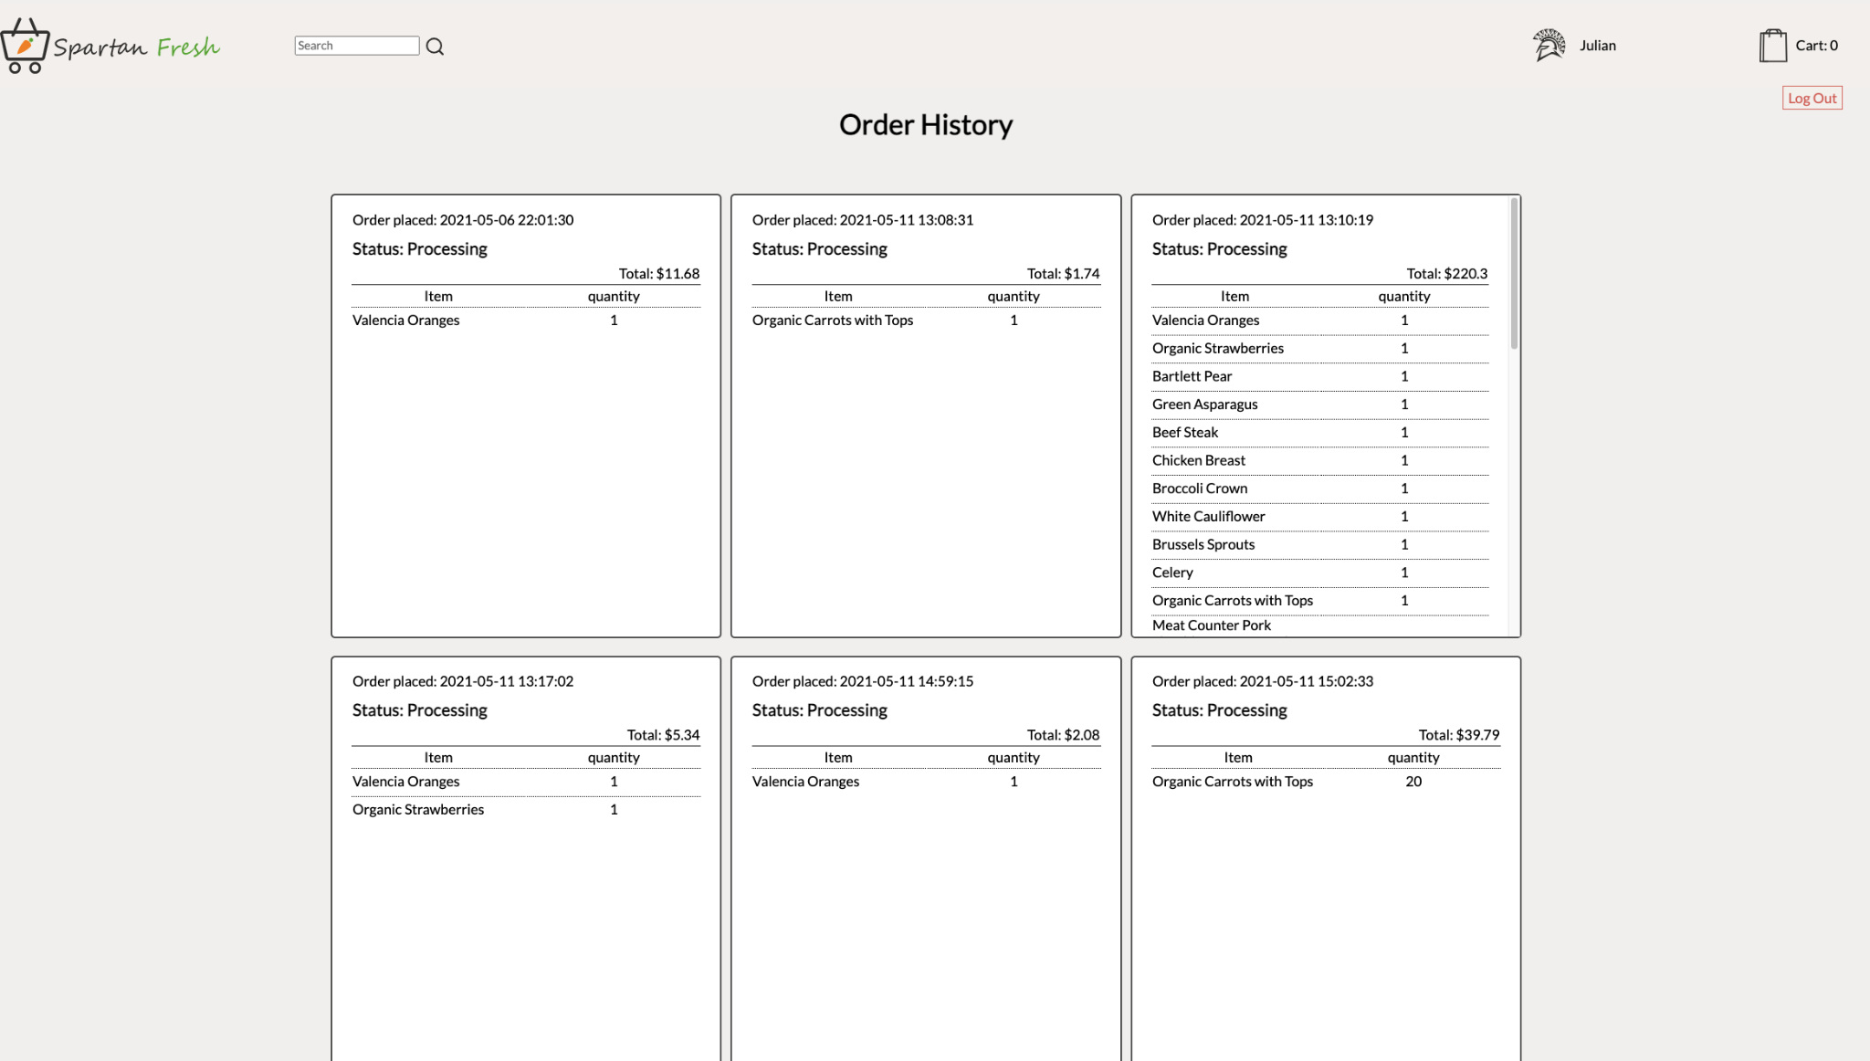

The “Order History” button will bring the user to the Order History Page. In this page, the user can see all the past orders with order date, total, status, all the items and quantity they bought before.

**Inventory Management**

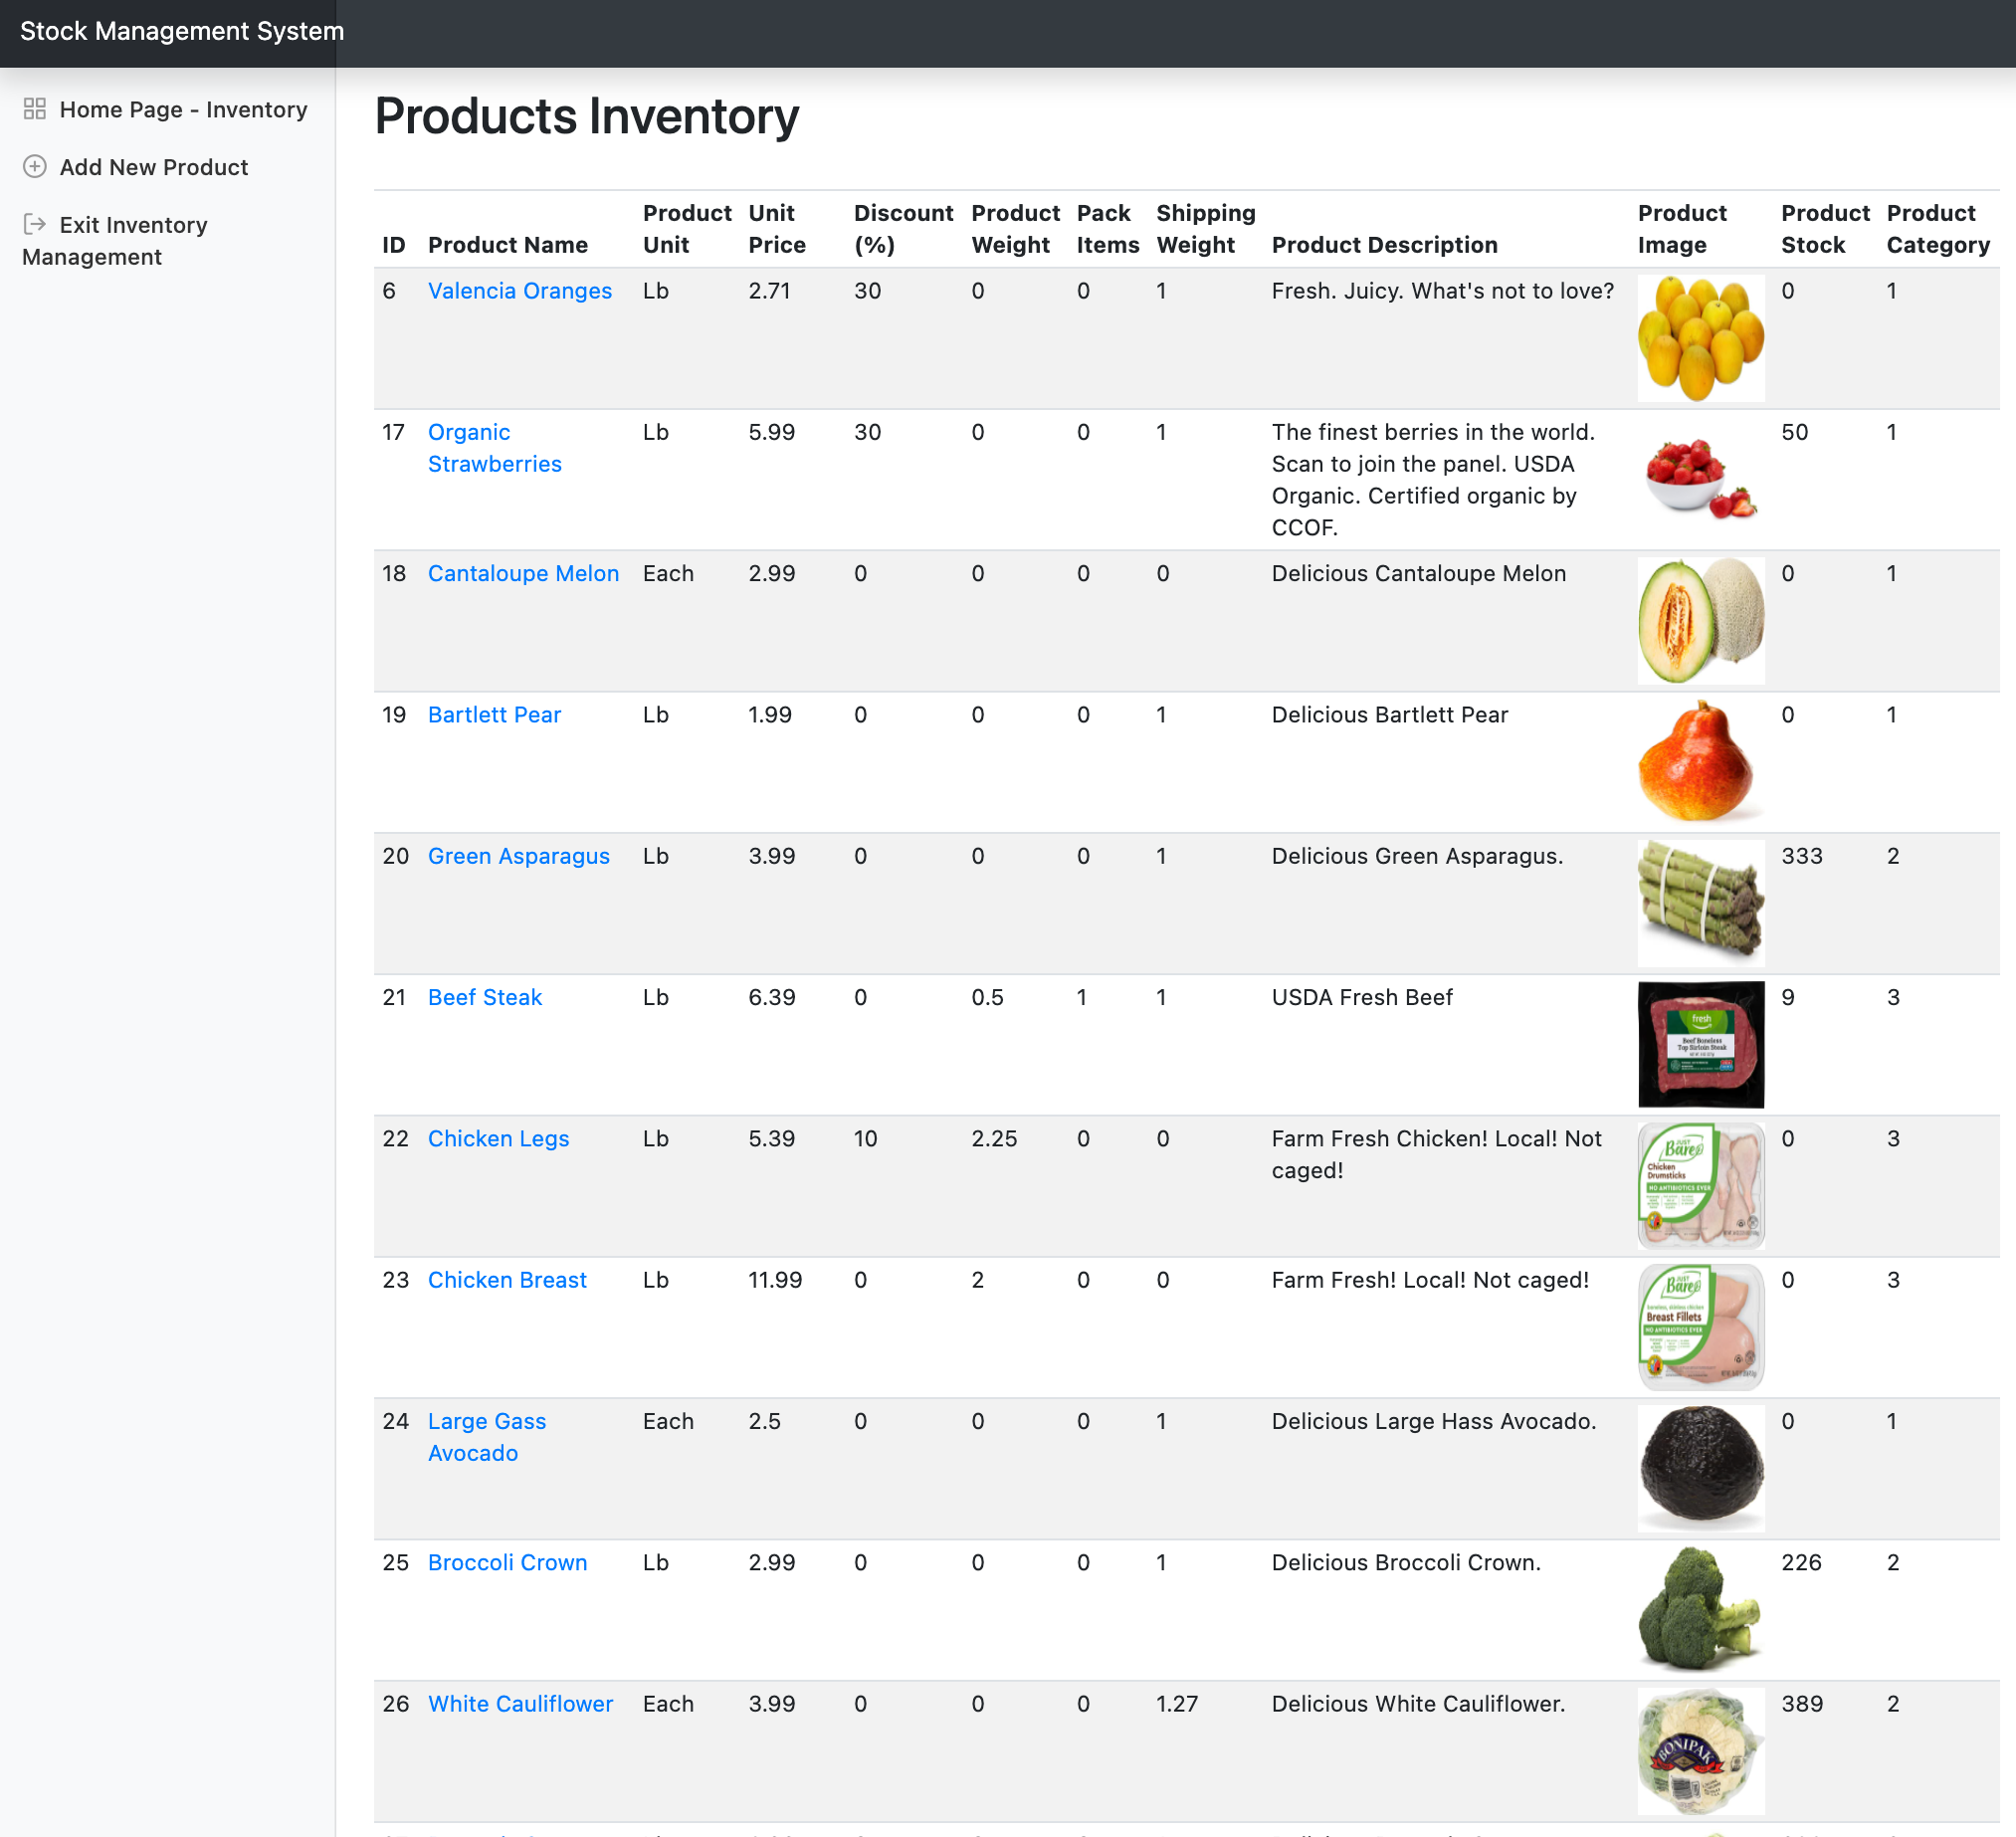

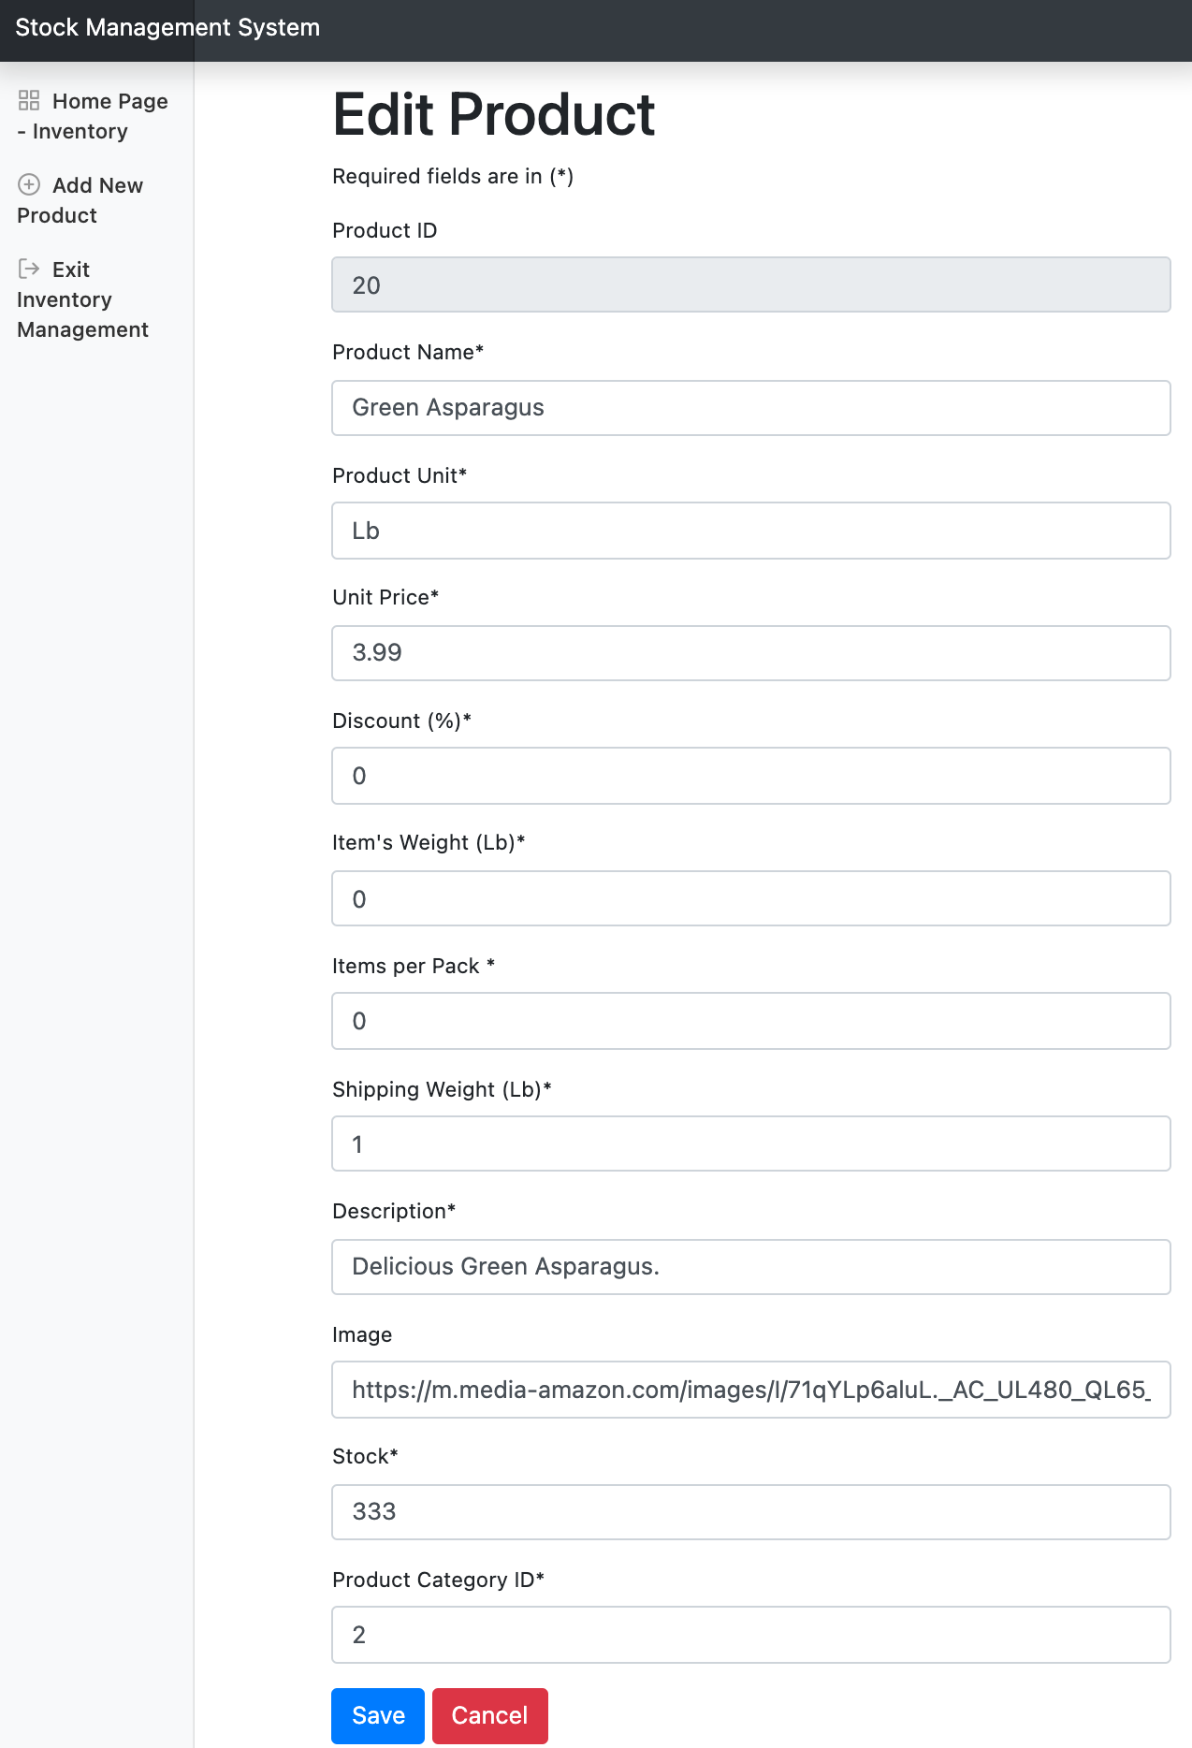 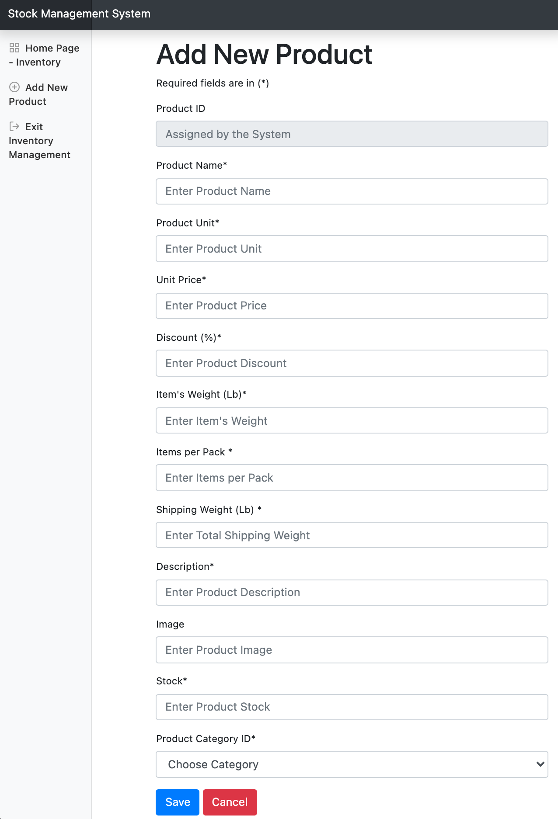

A retailer can access the admin portal using the normal login page. Once their credential is certified, the server directs the user to the inventory management system. Once logged in, the user can see the complete list of products offered on the Spartan Fresh website. The user can edit every attribute of existing products, add new products, and delete existing products.

**Database Connection**

